Q. Write a program in java to print “your name”.

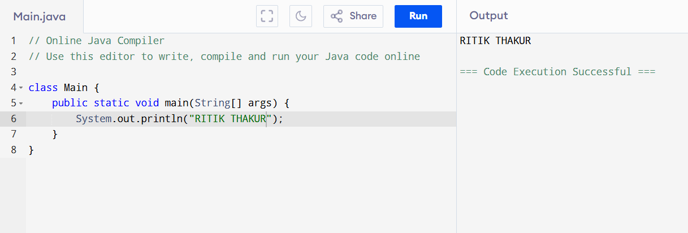

Q. Add two given numbers.

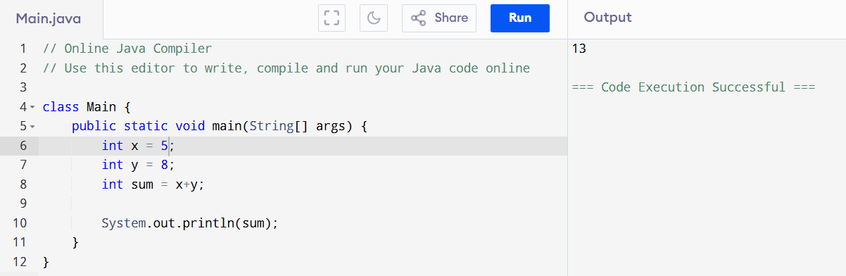

Q. Use all arithmetic operators.

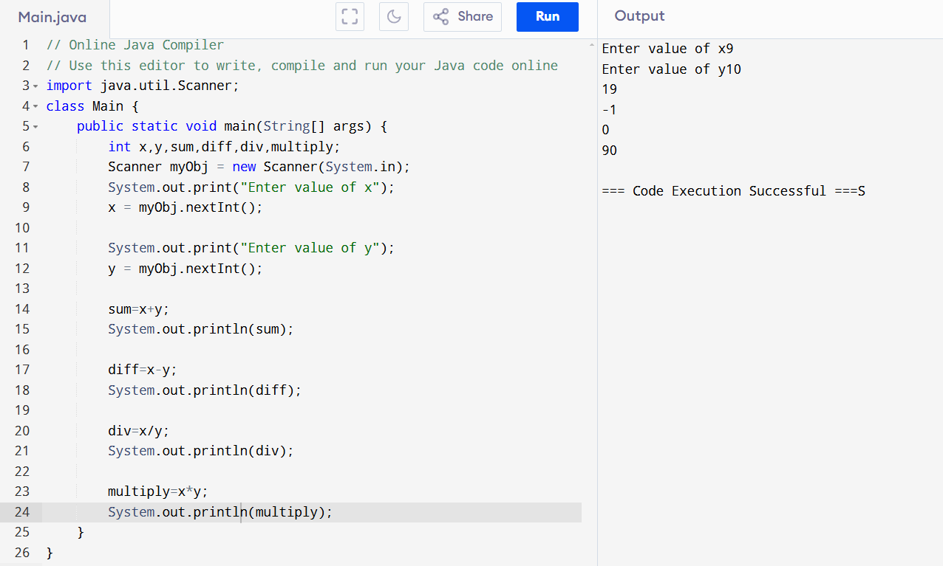

Q. Print name given by user.

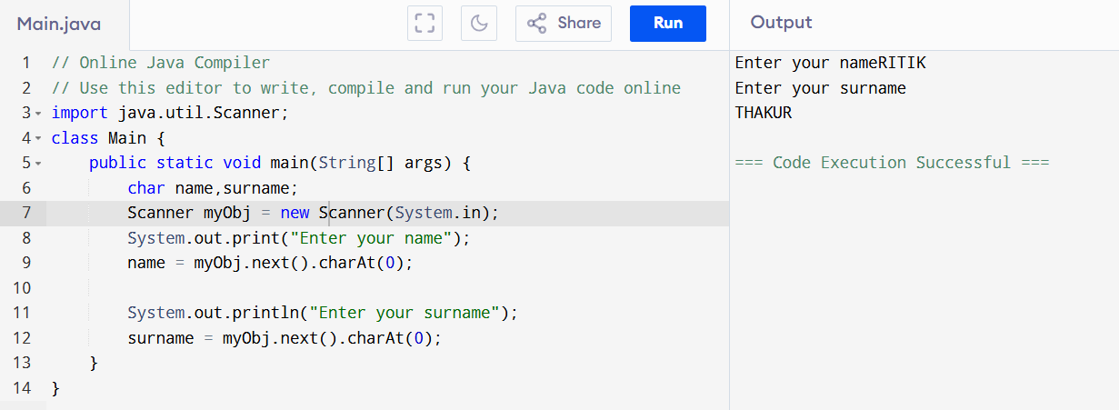

Q. Calaculate avg of two numbers.

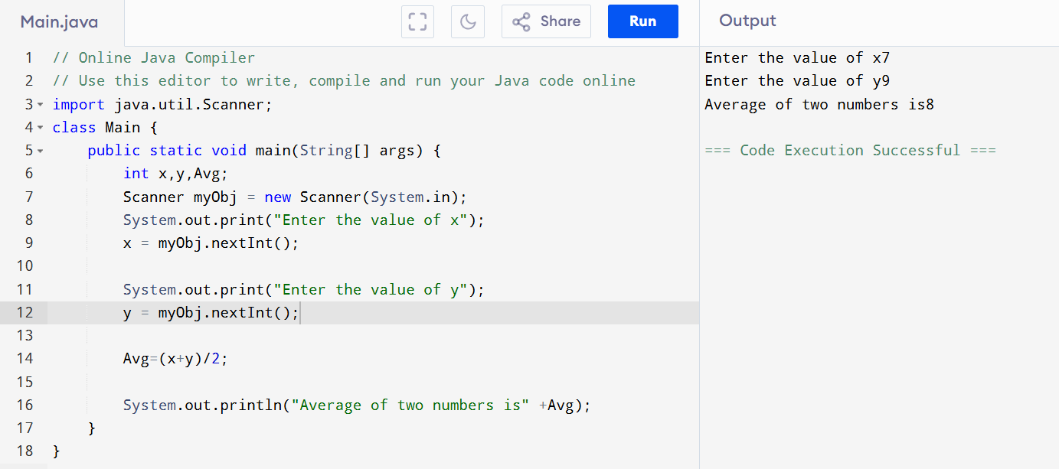

Q. Use modulus operator.

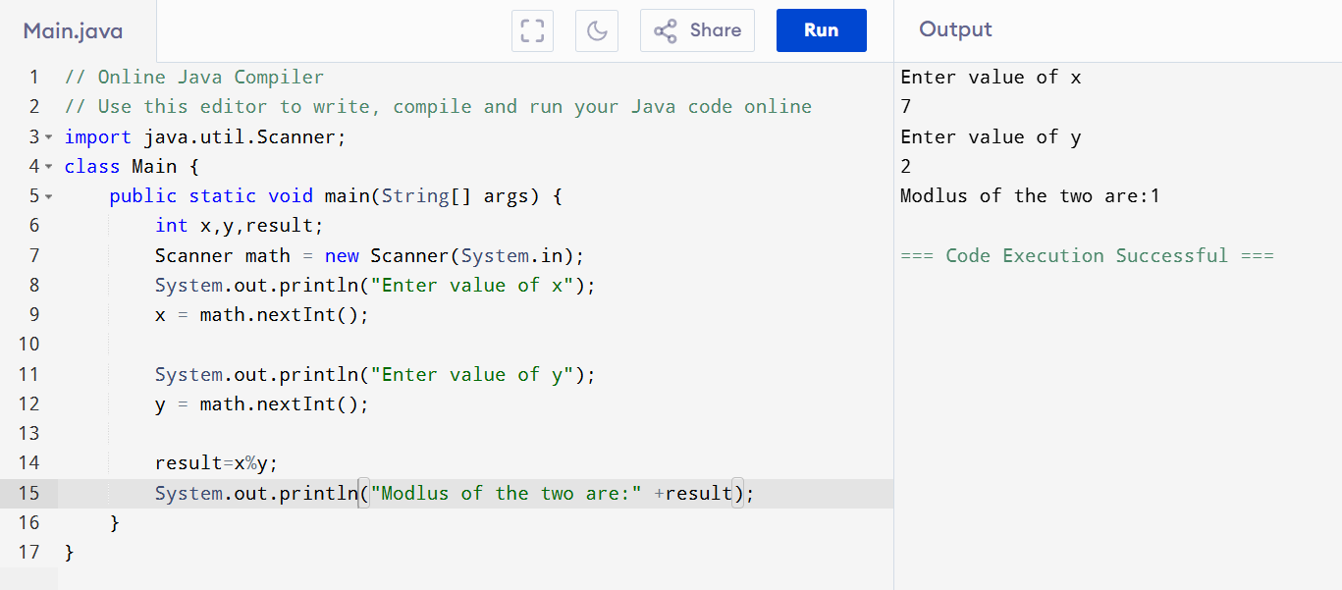

Q. Use Unary Operators.

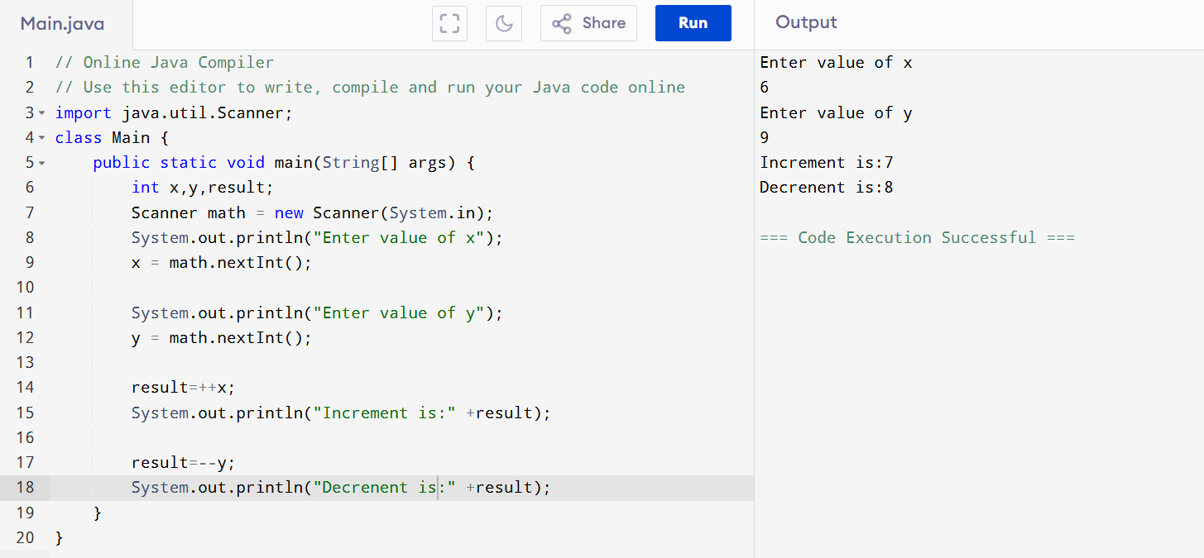

Q. Use all Relational Operators.

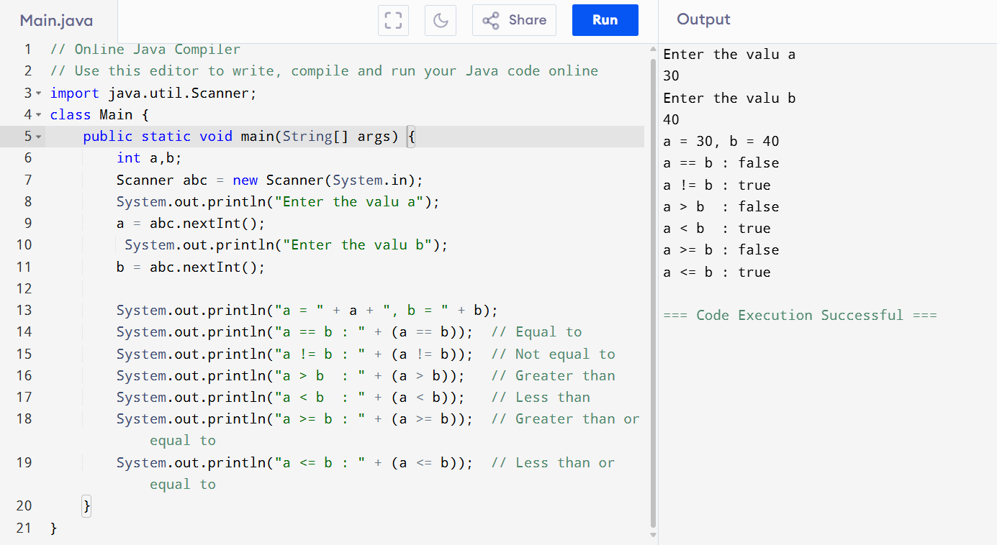

Q. Use Boolean data type.

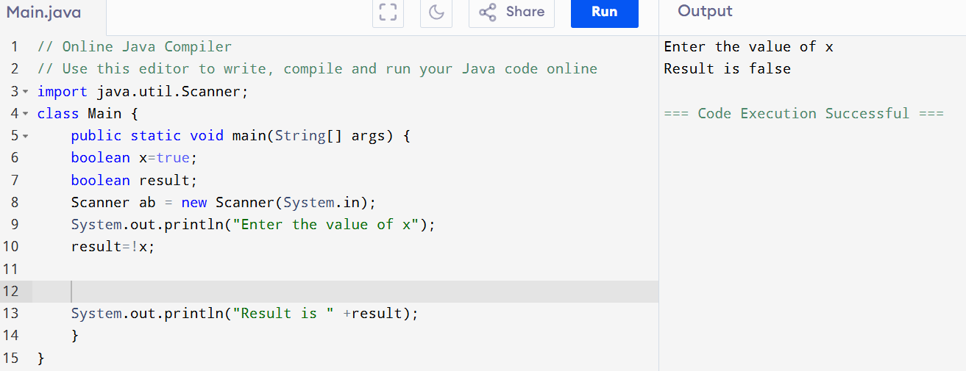

Q. Use of logical operator.

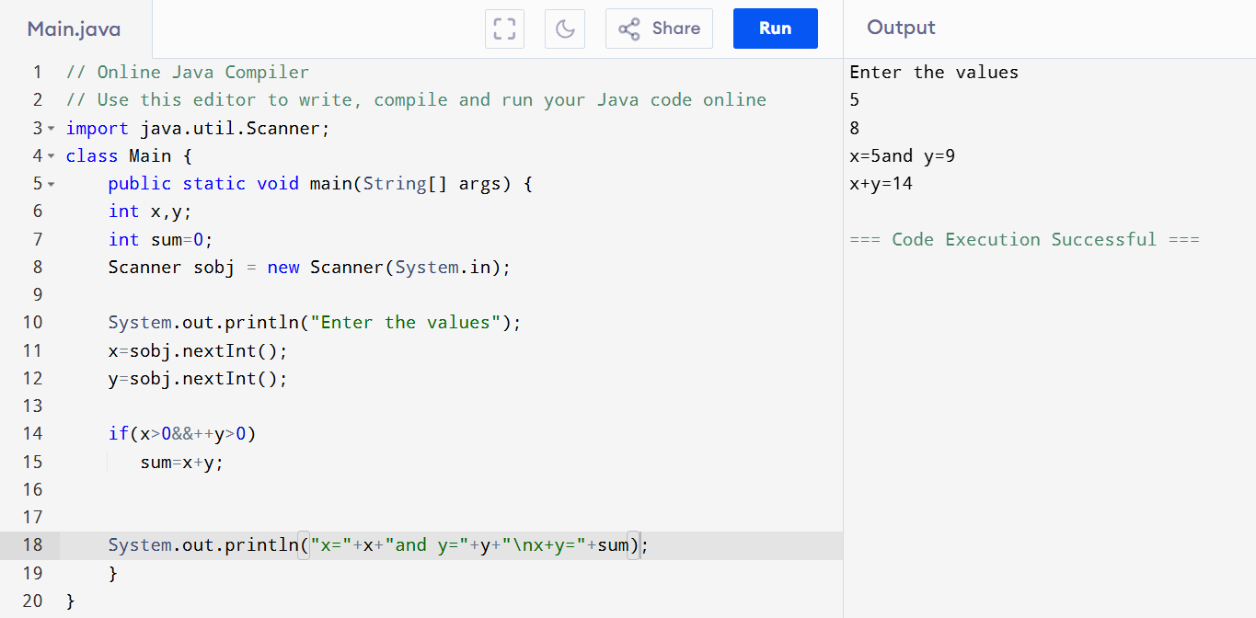

Q. Use all Assignment Operator.

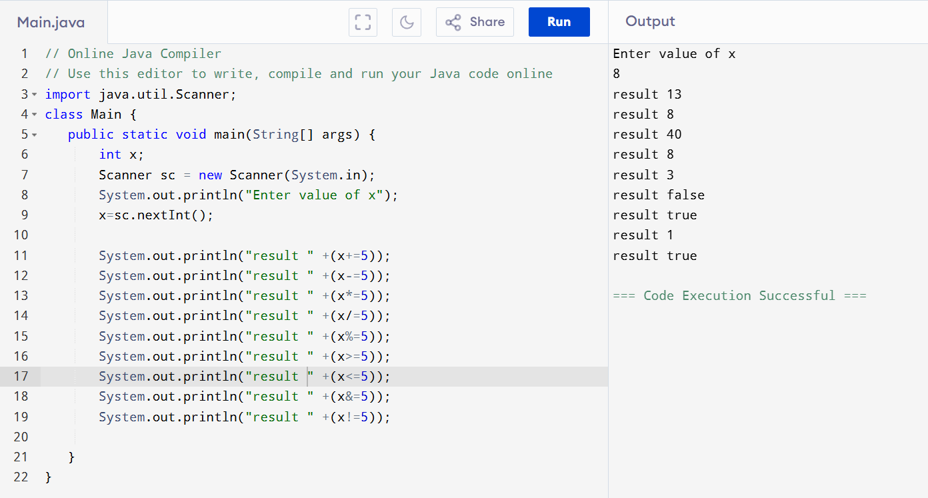

Q. Convert int to Boolean.

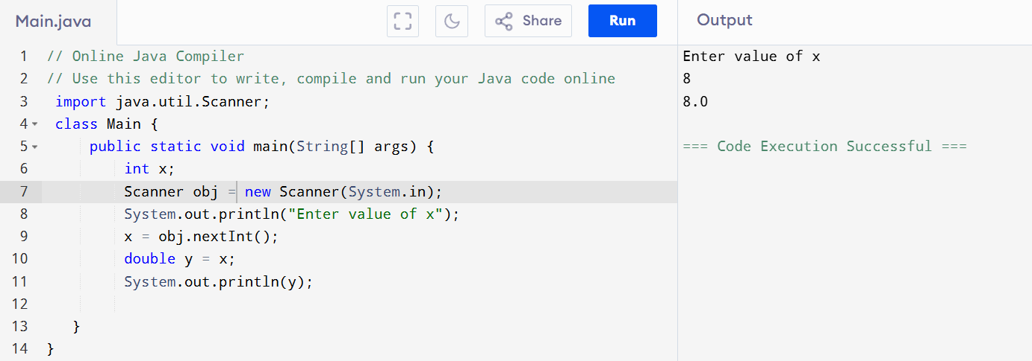

Q. Convert float to double.

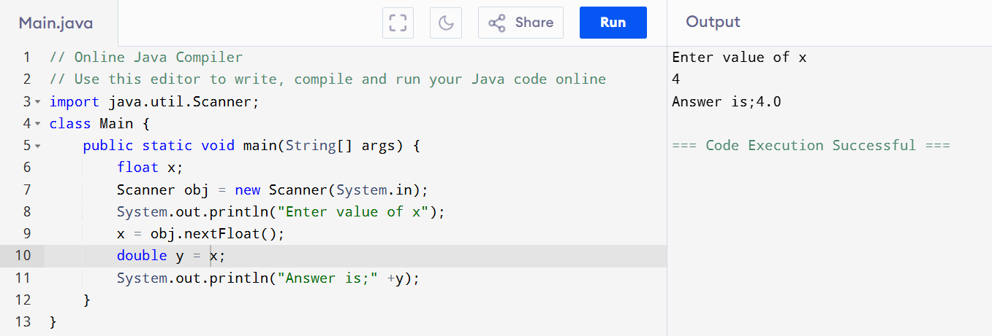

***Arrays in java***

Q. Enter the values in an array.

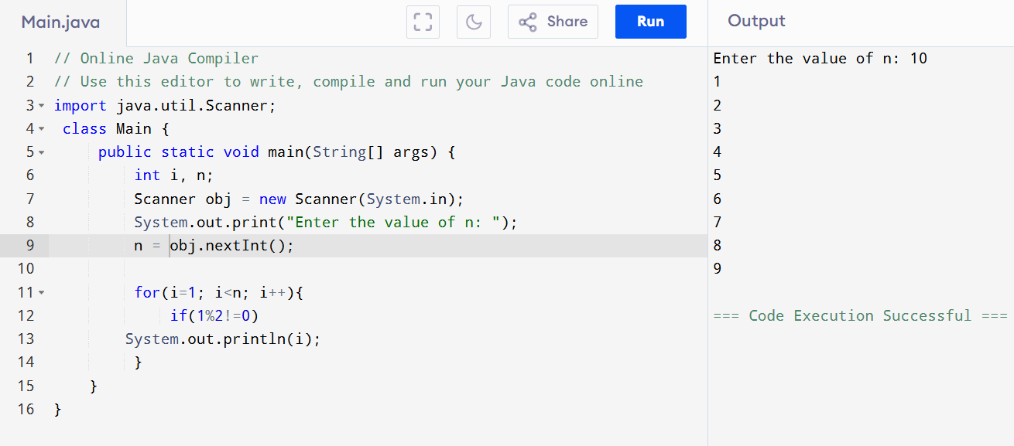

Q. WAP to print Factorial of a number given by user.

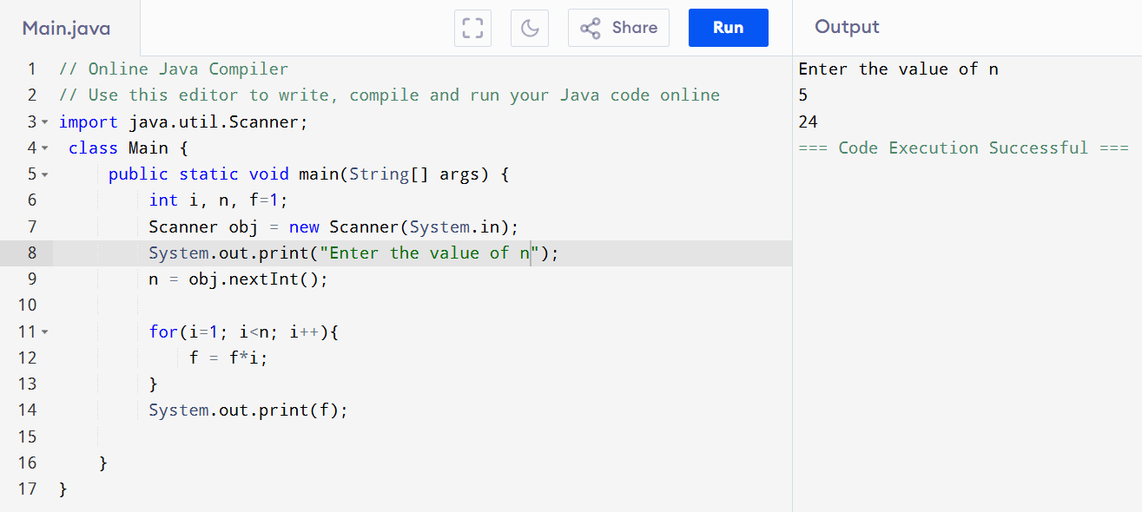

Q. WAP to print the sum of n numbers given by user.

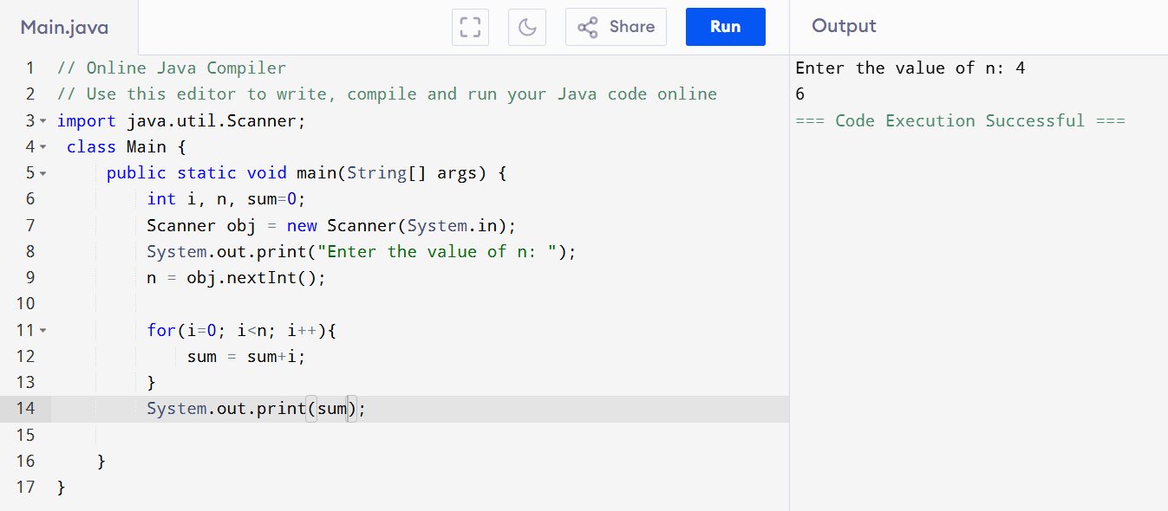

Q. WAP to print Fibonacci series.

